PSPP ON THE DEAD SEA BASINS
Ph.D. Jerusalem, Israel, Laureate of the Prize of the Council of Ministers of the USSR,
Netanya Branch of Israeli Independent Academy of Development of Science

Rosenberg Simyon
Ph.D., Lod, Israel, Scientific and Technical Association "Ecological imperative", Netanya Branch of Israeli Independent Academy of Development of Science
Email: semyon.rozenberg@gmail.com, tel.: +(972)524854666

Annotation
The authors propose building a pumped storage complex between the northern and southern Basins of the Dead Sea, including a Pumped Storage Power Plant (PSPP), an upper basin and a turbine conduit.

Key words: pumped storage complex, pumped storage power station, PSPP, upper and lower basins, dam, turbine conduit, closed water circuit, thermal power plants, energy cost, Dead Sea.

Purpose of the proposal
The technical significance of the proposed complex.
The turbines of the pumped storage power plant use the water from the upper pool, and the generators deliver electricity to the power grid at the optimal time.
Power equalization of Thermal Power Plants (TPP) will significantly increase their reliability. About 80% of repair and emergency stops of the thermal power plants are caused by rapid changes during operating mode.

The economic significance
The hydroaccumulation complex uses cheap electricity in pumping mode, and in generator mode it returns energy when its cost is noticeably higher.

PSPP State of the Art
PSPP is an established technology that has existed for more than a century. In many countries, a significant amount of PSPP plants with tens, hundreds and thousands of MW capacities were built. For example, according to the US Hydropower Market Status Report 2017, by the end of 2016, there were 38 PSPP projects, at a certain stages of the development, 32 of which were in the process of completing feasibility studies. [1]
PSPP is considered the most mature energy storage technology; most projects originate from the 1970s and 1980s, and its concept arose long before that. More than 170 GW are installed on the internationally and are in operating condition. Several proposals for the construction of a PSP were published in Israel, for example, [6, 7, 8,9 ,10]. However, no project is being implemented. In 2020, the total capacity of power plants in Israel exceeds 13,800 MW. A typical daily load curve of the power consumption for 2010 is shown in [2] At peak hours, as the graph shows, gas turbine stations are turned on, and at night, the power of thermal stations is reduced.

Description of the proposed pumped storage complex
The Upper Basin. The upper basin is located in a desert territory, with no economic activity. The upper basin is located 5 km North from Ein Bokek resorts. The upper basin is isolated from the northern and southern basins of the Dead Sea and therefore does not affect the environmental conditions of the southern basin of the Dead Sea, as well as the operation of the Israeli and Jordanian Dead Sea Plants. It important to note, that authors managed to find a unique place for the construction of the upper basin with the required specifications.
For the creation of a pumped storage complex with the required power - the upper basin must satisfy the following requirements:
-The upper basin must be pretty close to the northern basin of the Dead Sea.
- The triggering prism of the upper reservoir must have a volume of about 120 million m³ to equalize the daily operation of thermal stations and obtain a sufficient amount of peak and emergency power.
- Using the existing level difference between the upper basin and the northern basin of about 40m.
- Minimizing the length of additional dams forming the upper basin - in order to reduce the cost of its construction.

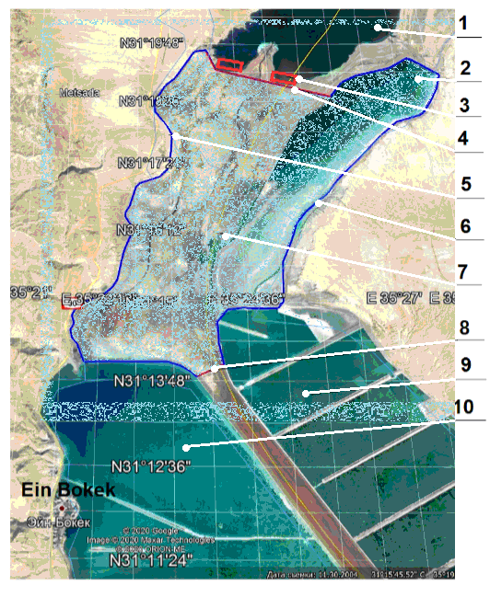
Fig. 1. The upper basin [Google Earth Pro].

In fig. 1 shows the upper basin (7). The area of the upper basin is 50 km² and is limited by dams of the Israelis and Jordanian Factories. The red lines show additional needed dams: (4) 4.2 km long with an average height of 22 m (415-393) and dam (8), 0.8 km long with an average height of 5 m. The blue lines (5 and 6) show the existing operational dams of the Plants with a total length of 32 km. The upper level of all dams is not lower than minus 393 m.
In addition to the facilities mentioned above, Figure 2 shows: 2 - part of the southern Jordanian basin, 9 - production basin of the Jordanian Dead Sea Plant, 10 - production basin of the Israeli Dead Sea Plant.
Figure 2 shows the profile of the bottom of the dam (4).

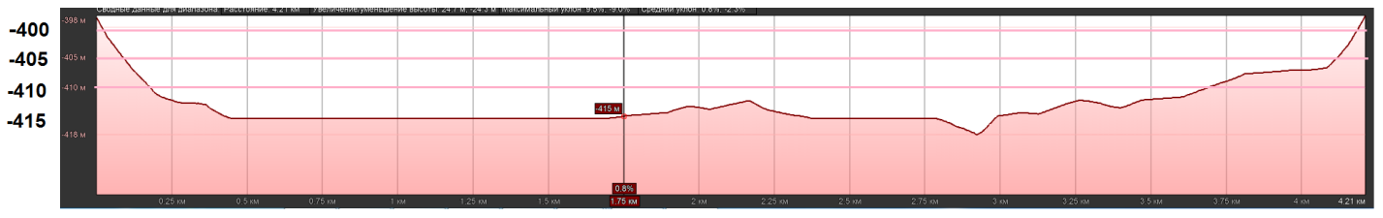
Figure 2. The profile of the bottom of the dam (4) [Google Earth Pro]

The PSPP buildings (3) are located directly under the additional dams at the bottom of the northern basin (1). Turbine pipelines run at minus 415 m to the pump intakes at minus 445 m and therefore have a minimum length of only 50 ... 100 m. The PSPP water intake is submerged below the level of the northern Dead Sea basin to minus 445 m. In the PSPP, several hydraulic units are used, which are connected as necessary. The turbine water conduit is made in the form of parallel pipes with a diameter of 3 ... 4 m. They are able to withstand a water pressure of about 50 m.

PSPP operation mode
In Fig. 3. shows a graph of daily changes in power consumption in Israel (summer 2010) [2].
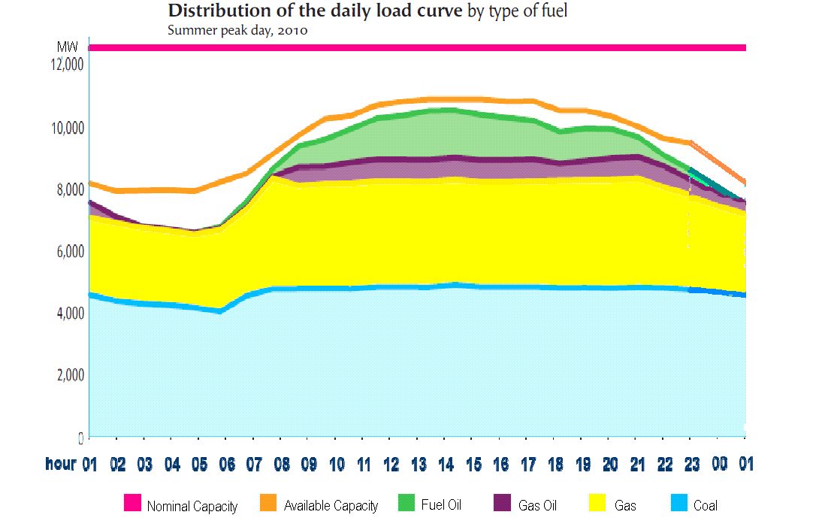
Fig. 3. Schedule of daily changes in power consumption in Israel (summer 2010) [2]

Israel daily power consumption has maximum power Pmax = 10930 MW and the minimum Pmin = 6670 MW.
For example, in Figure 4 shows a hypothetical graph in which we have a constant power of thermal stations Pconst. When consumption is less than Pconst, hydropower units accumulate energy by pumping water to the upper basin. When consumption is greater than Pconst, hydropower units generate energy by using water from the upper reservoir. The operating time during pumping mode is Tp = 14 hours (from the graph in Fig. 4), the operating time during the generating mode is Tg = 10 hours.
Based on these graph data, we calculate the stable power of thermal stations Pconst.
We estimate the efficiency in the pumping and generating modes around k = 0.87. Simple calculation gives Energy during pumping (Ep) and generating (Eg) modes are (here we assume that the power graphs could be approximated by parabola):
Ep = 2/3* Pp *Tp *k, Eg = 2/3* Pg* Tg / k.
Pmax=10930 MW, Pmin=6670 MW, deltaP=Pmax-Pmin=4260 MW, Tp=14 h, Tg=10 h, k=0.87.
Here Pp and Pg are the maximum powers during pumping and generating modes.
The energy Ep should be equal to the energy Eg. Hence we have Pp*Tp*k=Pg*Tg/k,
Pp*Tp*k ² =Pg*Tg, Pp*Tp*k ² =P*Tg-Pp*Tg, Pp(Tpk ² +Tg)= P*Tg,
Pp=P*Tg/(Tpk ² +Tg)=4260*10/(14*0.87 ² +10)= 2070 MW. Pg=4260-2070=2190 MW.
The PSPP delivers to the network per day in the generation mode Eg=2/3*2190*10=14600 MWh.

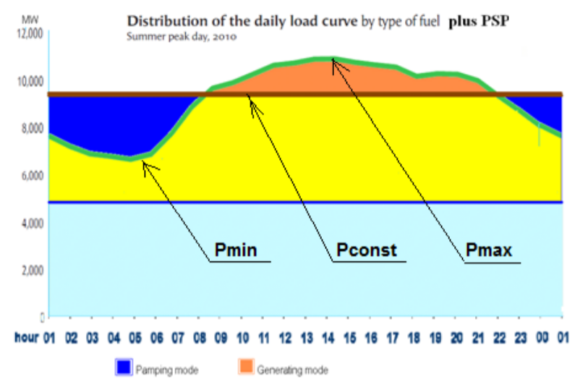
Fig. 4. Graph of the daily power consumption in Israel including the interaction of the PSPP with the country's electric grid.

The water level in the northern basin drops year after year, and in 2020 the level is below minus 435 meters. Water level in the southern basins of the Dead Sea Plants (both Israeli and Jordanian) is minus 395 m. Water level in the built upper basin can be set, for example, minus 393 m according to the height of existing and additionally built dams. Therefore, the level difference between the northern basin and the built upper basin is about H = 40 m.
The total daily water flow rate in the pumping and generating modes are Qр and Qg [m ³], water flow - q [m ³ / s], power P [W]. In the northern basin, water (brine) density is p = 1235 [kg / m³].
We calculate the maximum water flow and the total daily water amount:
Pgmax=2190 MW, Pg=g*р*q* H*k, q=Pg/g*р*H*k=2190000000/9.81*1235*40*0.87=5200 m ³ /s,
Qg=2/3 *q*Tg*3600=2400*10*5200= 125 Mm ³ .
Ppmax=2070 MW, Pp=g*p*q*H/k, q=k* Pp/g*p*H =0.87*2070000000/9.81*1235*40=3700 m ³ /s,
Qp=2/3 *q*Tp*3600=2400*14*3700= 125 Mm ³ .
The area of the constructed upper basin is 50 km², so the prism of operation
will be about 2.5 m (= 125/50).
As of 2010, the constant average daily power of thermal stations is Pconst = Pmax - Pg = 10930 - 2190 = 8740 MW.
When designing the future PSPP, increased energy consumption in Israel and the Kingdom of Jordan, should be taken into account as well as increase in the share of renewable energy.
Power plants in Israel amounted to 13800 MW in 2020; Jordan achieved 3312 MW capacity in 2012. [11]
The proposed hydro complex will not create any environmental problems in the resort area near Ein Bokek and the southern Dead Sea resorts. The healing properties of Dead Sea water and air will not alter either.

Construction payback
Most PSPP projects were developed in the 1970s and 1980s and, according to a report by the US Land Reclamation Bureau, cost of their accumulated energy is about $ 2020 / kW. The cost of the equipment of the power plant is $ 825 / kW, and the cost of earthwork (civil engineering) is $ 80 / kW. Depending on the terrain, the cost of tunnels, the upper tank and the lower tank can rich up to $ 420 / kW. In general, for a 10-hour storage period, the estimated Installed Capacity Cost (ICC) of a project with high-pressure (700+ feet) and high power (500+ MW) is from 2,600 to 3,100 US dollars / kW. The payback period for the construction of a pumped storage complex has long been proven by world practice - with thousands of built complexes and complexes under construction. [1].
In Israel, there is a table of tariffs by time of day and season. [3] For the proposed complex, tariffs are to be established by agreement with the electric company Hevrat Hashmal. In Israel, only due to different tariffs for energy consumption
The PSPP will generate millions of shekels of income.
In a first approximation, we assume that energy consumption throughout the year corresponds to the graph in Fig. 5, the average annual tariff per day, energy generation is 0.52 shekels per kWh, and the average annual tariff is 0.24 shekels per kWh.
The PSPP will supply to the network in the generation mode Eg = 2/3 * 2190 * 10 = 14600 MWh per day (see above). The cost of generating energy is 0.52 x 14600000 = 7,592,000 shekels. The PSPP consumes in the pumping mode Ep = 2/3 * 2070 * 14 = 19320 MWh/day. The cost of energy consumed in the pump mode 0.24 x 19320000 = 4,640,000 shekels. Income per day is 2.9 (=7,592-4,640) million shekels and for 300 working days a year 880 million shekels.
Estimated cost of construction of the complex (without need of the high-pressure dams), with a total capacity of 2,000 MW, is about $ 1 billion [1, 4, 5]. Estimated payback time will be no more than 5 years.
The payback period for a field of 41 wind turbines in Israel, scheduled for construction in 2022, is expected to be 8 years. [13].
In the Russian Federation, the Leningrad PSPP has been designed and is under construction. (2017)[12] Leningrad PSPP has capacities similar to those proposed PSPP: 1560/1760 MW (in generator / pump modes). The estimated cost of the project is 73.8 billion rubles, i.e. about $ 1 billion. This similarity will us advantage and could significantly reduce the cost of the proposed PSPP.
The upper basin is partially located in the Kingdom of Jordan. It will allow the Kingdom to take advantage of all the benefits of the project and received additional income from the operating PSPP. Also providing its territory for the station, the Kingdom will receive additional energy source. This will reduce financial load on Jordan since she imports over 90% of its energy resources.
The article considers only energy problems. The authors estimated the cost facilities according to the data taken from Internet. With real design and construction and taking into account the required capacities, the cost of the project and the payback time will be slightly different.

Possible sponsors
It is proposed to attract sponsors from charitable environmental organizations and the UN to solve a regional environmental problem - the accumulation of energy from solar power plants. There are more than a dozen such funds that participate in financing environmental projects in different countries, for example:
World Bank [5], United Nations Foundation, UNF [6], David and Lucille Packard Foundation [7], United Nations Environment Programme, UNEP [8] and others [9].
To solve a regional environmental problem, you can send an application to each sponsorship fund for their participation in financing the construction of the Complex.

BIBLIOGRAPHY
1.https://energystorage.pnnl.gov/pdf/PNNL-28866.pdf
2. http://www.renewableenergyworld.com/rea/news/article/2010/10/worldwide-pumped-storage-activity
3. http://www.ide-tech.com/wp-content/uploads/2013/09/The-Operation-Principle-of-the-
Hadera-Seawater-Desalination-Plant-and-Advantages-of-the-Pressure-Center-Design.pdf
4. http://www.necu.org.ua/upl/IP_Kaniv_PSP_May_08_rus.pdf
5. http://bravenewclimate.com/2010/04/05/pumped-hydro-system-cost/
6. http://www.elektron2000.com/article/1647.html
7. http://elektron2000.com/article/1685.html
8. http://netanyascientific.com/0/CONFERENCE%20Netania%202019.pdf -стр. 67
9. http://netanyascientific.com/Stati/Stati-7/data/Pumpstorstate.pdf
10. http://netanyascientific.com/English/Stati/Stati-7/data/Pump_power_plant.pdf
11. https://energypedia.info/wiki/Jordan_Energy_Situation
12. https://ru.wikipedia.org/wiki/%D0%9B%D0%B5%D0%BD%D0%B8%D0%BD%D0%B3%D1%80%D0%B0%D0%B4%D1%81%D0%BA%D0%B0%D1%8F_%D0%93%D0%90%D0%AD%D0%A1
[13]. https://detaly.co.il/na-golanskih-vysotah-budet-realizovan-masshtabnyj-proekt-v-sfere-zelenoj-energetiki/

